PRESS RELEASE

WRX « S » HYBRID PIRATES / PIRATES SHADOW

20 May 2015

The Pirate spirit is back!

Spread the word ... The Pirates are back! Or at least their spirit ... Since forever the pirates – from the latin pirata "anyone trying fortune, which is entrepreneurial" - have chosen a different path. This is also the philosophy RALF TECH follows: loudly asserting our values of independence and expertise by choosing alternative routes.
RALF TECH has been always a brand associated with the sea and its mysteries… it is a remarkably different and irreverent brand. Why not then reincarnate such features in timepiece at the same time earnest and provocative?
WRX « S » Hybrid Pirate affirms its solid credentials without hesitation: second generation Hybrid Movement, bezel in Céramfine® (a super strong alloy of ceramic and titanium), optimal legibility, real water resistance to 500 metres… all of the above conjure to make this extreme tool ideal for marine adventures.
WRX « S » Hybrid Pirate is provocative to the point of no return. It is an invitation to travel across the infinite horizons, to be inspired by the spirit of the pioneer; behind its dial a world of adventure awaits.
It was about time to celebrate the vast number of great skippers who wear a RALF TECH… The «Pirates» and « Pirates Shadow » timepieces pay a disrespectful homage to all those skippers, famous or less known, who wear a RALF TECH.

And finally, of course, it was the perfect opportunity to reaffirm, through a nonlinear and innovative timepiece, RALF TECH spirit of independence.
Et c’est enfin, bien évidemment, l’occasion de réaffirmer, à travers une pièce décalée, l’indépendance d’esprit de RALF TECH.

…/…

The WRX « S » Hybrid « Pirates »

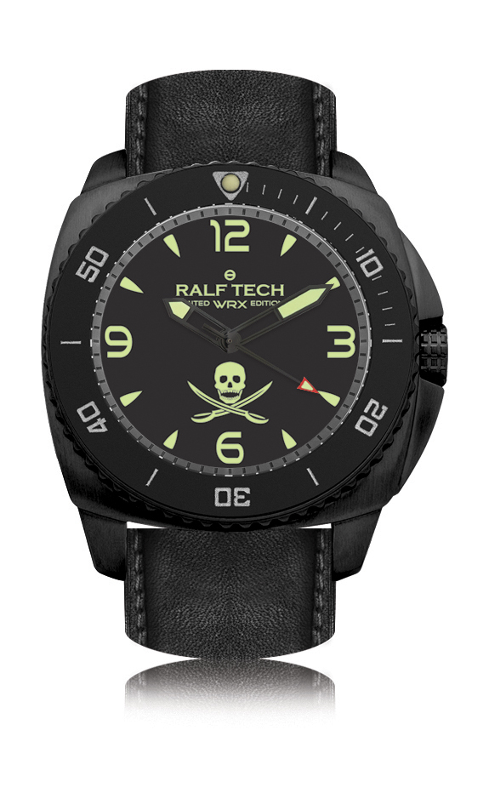
WRX « S » Hybrid « Pirates » Technical Features
- Movement Hybrid RTH002®
- Exclusive quartz system with automatic accumulator recharge
- Ultra-fast rotor
- Power reserve of 150 days
- Tested water resistant up to 500M / 1650FT
- Complies with ISO 6425 dive watches standard
- Hours, minutes, seconds, elapsed immersion time
- Matt Black pvd 316L surgical case, diameter 47.5 mm (without crown)
- Matt black dial 95%
- Domed antiglare sapphire crystal 5.9 mm thick
- Professional "Superluminova®" C3 hands and hour markers
- Unidirectional rotating Steel bezel, with ceramic Ceramfine® insert, matt black finish
- Screw down case back engraved with individual serial number
- Reinforced and protected screw-down crown
- Black Barenia calf leather strap and black silicone strap, mounted on 26mm screwed bars, oval holes, 26mm matching buckle
- Comes in a waterproof anti shock NATO approved case
- Series limited to 300 pieces

The WRX « S » Hybrid « Pirates Shadow »

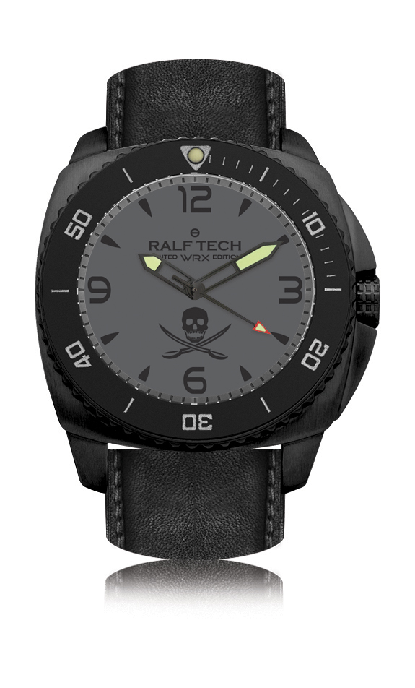

WRX « S » Hybrid « Pirates Shadow» Technical Features
- Movement Hybrid RTH002®
- Exclusive quartz system with automatic accumulator recharge
- Ultra-fast rotor
- Power reserve of 150 days
- Tested water resistant up to 500M / 1650FT
- Complies with ISO 6425 dive watches standard
- Hours, minutes, seconds, elapsed immersion time
- Matt Black pvd 316L surgical case, diameter 47.5 mm (without crown)
- Phantom grey dial
- Domed (internal antiglare treatment) sapphire crystal 5.9 mm thick
- Matt black hands and black hour markers
- Unidirectional rotating Steel bezel, with ceramic Ceramfine® insert, black matt finish
- Reinforced and protected screw-down crown
- Screw down case back engraved with individual serial number
- Black Barenia calf leather strap and black silicone strap, mounted on 26mm screwed bars, oval holes, 26mm matching buckle
- Comes in a waterproof anti shock NATO approved case
- Series limited to 300 pieces

Recommended retail price: 1890€

Availability : From 22nd May in all the RALF TECH Authorised Dealers and COLETTE

For a list of retailers: www.ralftech.com
Customer Services: contact@ralftech.com

